Key Decisions of the Solitaire Project

Object-oriented programming language - Python
GUI library - CustomTkinter
IDE - Visual Studio Code
xUnit framework - unittest (PyUnit)
Programming style guide - Google Python Style Guide
Project hosting site - Github.com

Unit testing
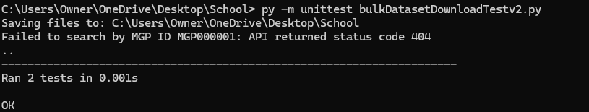

GUI Programming
